Project Report
Employees Absenteeism
Rohit Raj
9th february 2019

Contents
1. Introduction
1.1 Problem Statement . . . . . . . . . . . . . . . . . . . . . . . . . . . . . . . . .. . . . . . . . . . 3
1.2 Data . . . . . . . . . . . . . . . . . . . . . . . . . . . . . . . . . . . . . . . . . . . . . . . . . . . . . . 3
1.3 Exploratory Data Analysis . . . . . . . . . . . . . . . . . . . . . . . . . . . . . . . . . . . . . 5
2. Methodology
2.1 Pre Processing . . . . . . . . . . . . . . . . . . . . . . . . . . . . . . . . . . . . . . . . . . . . . . 6
2.1.1 Missing Value Analysis . . . . . . . . . . . . . . . . . . . . . . . . . . . . . . . . . . . . . .8
2.1.2 Outlier Analysis . . . . . . . . . . . . . . . . . . . . . . . . . . . . . . . . . . . . . . . . . . . 12
2.1.3 Feature Selection . . . . . . . . . . . . . . . . . . . . . . . . . . . . . . . . . . . . . . . . . . 16
2.1.4 Feature Scaling . . . . . . . . . . . . . . . . . . . . . . . . . . . . . . . . . . . . . . . . . . . 18
2.1.5 Principal Component Analysis . . . . . . . . . . . . . . . . . . . . . . . . . . . . . . . 18
2.2 Modeling . . . . . . . . . . . . . . . . . . . . . . . . . . . . . . . . . . . . . . . . . . . . . . . . . . 20
2.2.1 Decision Tree. . . . . . . . . . . . . . . . . . . . . . . . . . . . . . . . . . . . . . . . . . . . . 20
2.2.2 Random Forest . . . . . . . . . . . . . . . . . . . . . . . . . . . . . . . . . . . . . . . . . . . .21
2.2.3 Linear Regression . . . . . . . . . . . . . . . . . . . . . . . . . . . . . . . . . . . . . . . . . 21
2.2.4 Gradient Boosting . . . . . . . . . . . . . . . . . . . . . . . . . . . . . . . . . . . . . . . . . 22
3. Conclusion
3.1 Model Evaluation . . . . . . . . . . . . . . . . . . . . . . . . . . . . . . . . . . . . . . . . . . . 23
3.2 Model Selection . . . . . . . . . . . . . . . . . . . . . . . . . . . . . . . . . . . . . . . . . . . . .23
3.3 Answers of asked questions . . . . . . . . . . . . . . . . . . . . . . . . . . . . . . . . . . . 23
Appendix
Extra Figures . . . . . . . . . . . . . . . . . . . . . . . . . . . . . . . . . . . . . . . . . . . . . . . . . 33
References . . . . . . . . . . . . . . . . . . . . . . . . . . . . . . . . . . . . 35

Chapter 1
Introduction

  - Problem Statement
XYZ is a courier company. As we appreciate that human capital plays an important role in collection, transportation and delivery. The company is passing through genuine issue of Absenteeism. The company has shared it dataset and requested to have an answer on the following areas:
1. What changes company should bring to reduce the number of absenteeism?
2. How much losses every month can we project in 2011 if same trend of absenteeism continues?

  - Data
There are 21 variables in our data in which 20 are independent variables and 1 (Absenteeism time in hours) is dependent variable. Since our target variable is continuous in nature, this is a regression problem.
Variables Information:
1. Individual identification (ID)
2. Reason for absence (ICD) -
Absences attested by the International Code of Diseases (ICD) stratified into 21 categories (I to XXI) as follows:
I. Certain infectious and parasitic diseases
II. Neoplasms
III. Diseases of the blood and blood-forming organs and certain disorders involving the immune mechanism
IV. Endocrine, nutritional and metabolic diseases
V. Mental and behavioral disorders
VI. Diseases of the nervous system
VII. Diseases of the eye and adnexa
VIII. Diseases of the ear and mastoid process
IX. Diseases of the circulatory system
X. Diseases of the respiratory system
XI. Diseases of the digestive system
XII. Diseases of the skin and subcutaneous tissue
XIII. Diseases of the musculoskeletal system and connective tissue
XIV. Diseases of the genitourinary system
XV. Pregnancy, childbirth and the puerperium
XVI. Certain conditions originating in the perinatal period
XVII. Congenital malformations, deformations and chromosomal abnormalities
XVIII. Symptoms, signs and abnormal clinical and laboratory findings, not elsewhere classified
XIX. Injury, poisoning and certain other consequences of external causes
XX. External causes of morbidity and mortality
XXI. Factors influencing health status and contact with health services
And 7 categories without (CID) patient follow-up (22), medical consultation (23), blood donation (24), laboratory examination (25), unjustified absence (26), physiotherapy (27), dental consultation (28).
3. Month of absence
4. Day of the week (Monday (2), Tuesday (3), Wednesday (4), Thursday (5), Friday (6))
5. Seasons (summer (1), autumn (2), winter (3), spring (4))
6. Transportation expense
7. Distance from Residence to Work (kilometers)
8. Service time
9. Age
10. Work load Average/day
11. Hit target
12. Disciplinary failure (yes=1; no=0)
13. Education (high school (1), graduate (2), postgraduate (3), master and doctor (4))
14. Son (number of children)
15. Social drinker (yes=1; no=0)
16. Social smoker (yes=1; no=0)
17. Pet (number of pet)
18. Weight
19. Height
20. Body mass index
21. Absenteeism time in hours (target)

1.3 Exploratory Data Analysis
Exploratory Data Analysis (EDA) is an approach to analyzing data sets to summarize their main characteristics. In the given data set there are 21 variables and data types of all variables are either float64 or int64. There are 740 observations and 21 columns in our data set. Missing value is also present in our data.
List of columns and their number of unique values -
ID 36
Reason for absence 28
Month of absence 13
Day of the week 5
Seasons 4
Transportation expense 24
Distance from Residence to Work 25
Service time 18
Age 22
Work load Average/day 38
Hit target 13
Disciplinary failure 2
Education 4
Son 5
Social drinker 2
Social smoker 2
Pet 6
Weight 26
Height 14
Body mass index 17
Absenteeism time in hours 19

From EDA we have concluded that there are 10 continuous variables and 11 categorical variables in nature.

Chapter 2
Methodology
Before feeding the data to the model we need to clean the data and convert it to a proper format. It is the most crucial part of data science project we spend almost 80% of time in it.
2.1 Pre Processing
Any predictive modeling requires that we look at the data before we start modeling. However, in data mining terms looking at data refers to so much more than just looking. Looking at data refers to exploring the data, cleaning the data as well as visualizing the data through graphs and plots. This is often called as Exploratory Data Analysis. To start this process we will first try and look at all the probability distributions of the variables. Most analysis like regression, require the data to be normally distributed. We can visualize that in a glance by looking at the probability distributions or probability density functions of the variable.

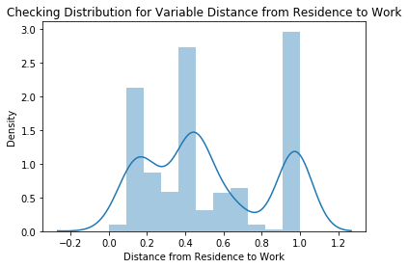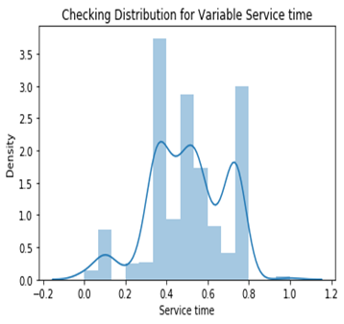

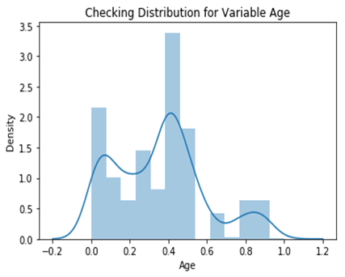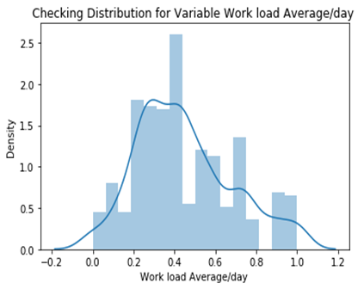

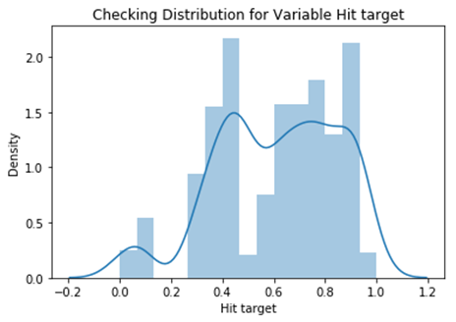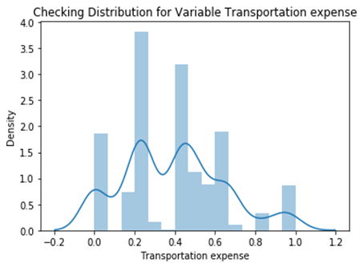

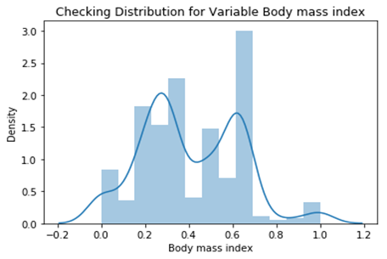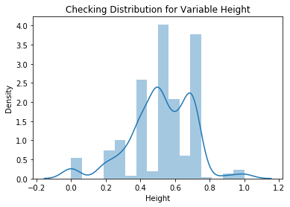

2.2.1 Missing Value Analysis
In statistics, missing data, or missing values, occur when no data value is stored for the variable in an observation. Missing data are a common occurrence and can have a significant effect on the conclusions that can be drawn from the data. If a columns has more than 30% of data as missing value either we ignore the entire column or we ignore those observations. In the given data the maximum percentage of missing value is 4.189% for body mass index column. So we will compute missing value for all the columns.
In this project we have used KNN imputation method to impute missing value in R and we have used Mean and Median method in Python.

We can see in below table which is organized in Descending order of highest Missing %

1 | Body.mass.index | 4.1891892
2 | Absenteeism.time.in.hours | 2.9729730
3 | Height | 1.8918919
4 | Work.load.Average.day. | 1.3513514
5 | Education | 1.3513514
6 | Transportation.expense | 0.9459459
7 | Hit.target | 0.8108108
8 | Disciplinary.failure | 0.8108108
9 | Son | 0.8108108
10 | Social.smoker | 0.5405405
11 | Reason.for.absence | 0.4054054
12 | Distance.from.Residence.to.Work | 0.4054054
13 | Service.time | 0.4054054
14 | Age | 0.4054054
15 | Social.drinker | 0.4054054
16 | Pet | 0.2702703
17 | Month.of.absence | 0.1351351
18 | Weight | 0.1351351
19 | ID | 0.0000000
20 | Day.of.the.week | 0.0000000
21 | Seasons | 0.0000000

Now we will see the same missing % in Graph like Bar plot and Heat map.
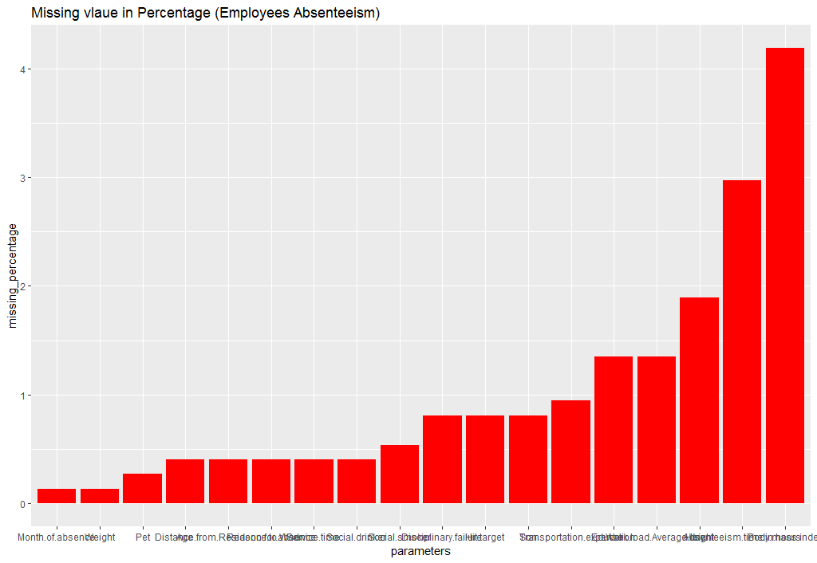
Total NA value in the dataset is =135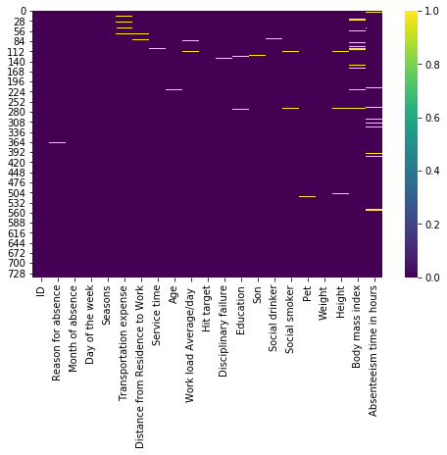

After Imputing Missing Value My Heat map look like this-
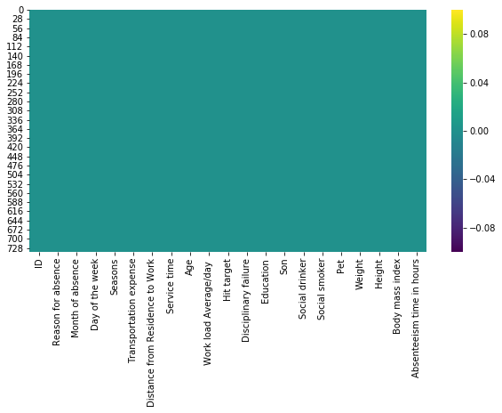
Above we can see there is no yellow dash to indicate missing value. We have completely removed this.

2.1.2 Outlier Analysis
We can clearly observe from these probability distributions that most of the variables are skewed. The skew in these distributions can be most likely explained by the presence of outliers and extreme values in the data. One of the other steps of pre-processing apart from checking for normality is the presence of outliers. In this case we use a classic approach of removing outliers. We visualize the outliers using boxplots.
In figure we have plotted the boxplots of the 11 predictor variables with respect to Absenteeism time in hour. A lot of useful inferences can be made from these plots. First as you can see, we have a lot of outliers and extreme values in each of the data set.

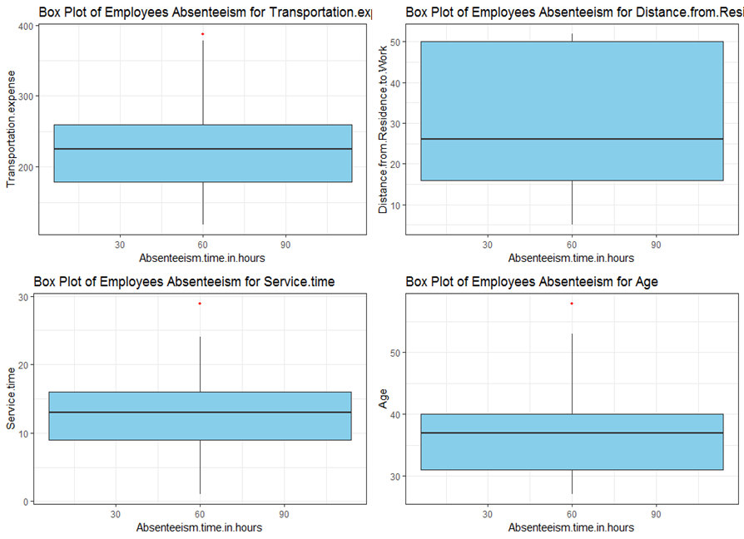

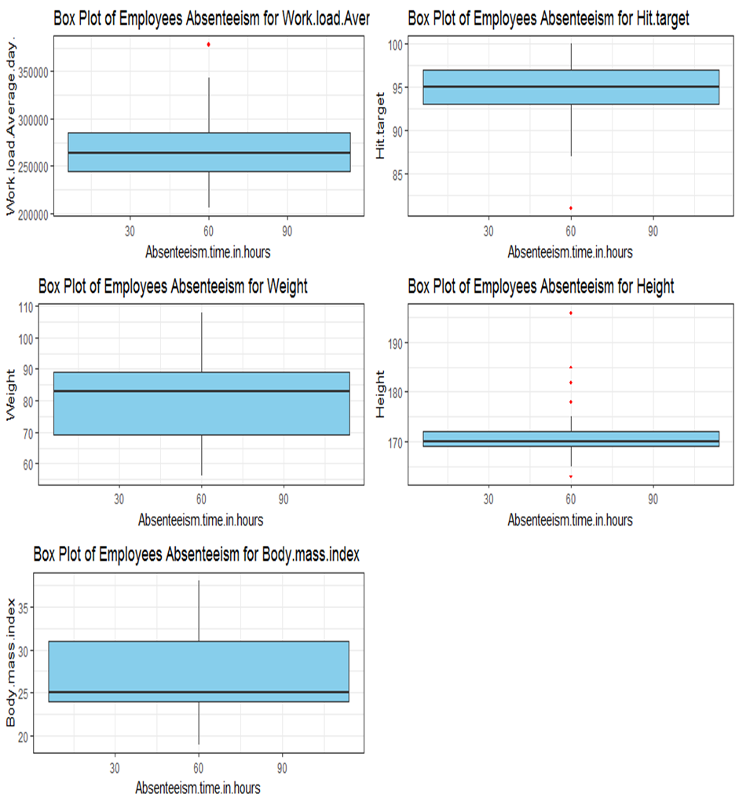

From the boxplot almost all the variables except “Distance from residence to work”, “Weight” and “Body mass index” consists of outliers. We have converted the outliers (data beyond minimum and maximum values) as NA i.e. missing values and fill them by KNN imputation method.

Below we can see new Boxplot to make sure that I have removed outliers:

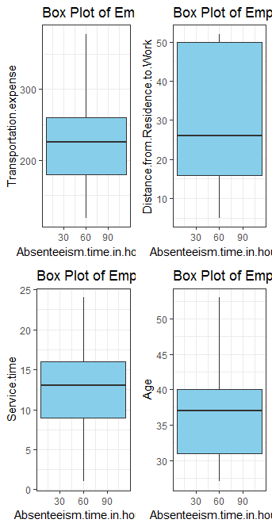
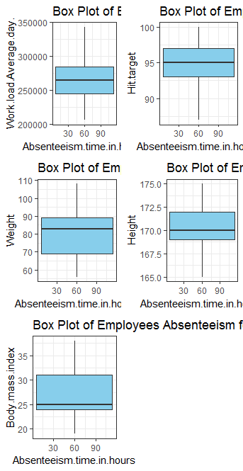

2.1.3 Feature Selection
Before performing any type of modeling we need to assess the importance of each predictor variable in our analysis. There is a possibility that many variables in our analysis are not important at all to the problem of class prediction. Selecting subset of relevant columns for the model construction is known as Feature Selection. We cannot use all the features because some features may be carrying the same information or irrelevant information which can increase overhead. To reduce overhead we adopt feature selection technique to extract meaningful features out of data. This in turn helps us to avoid the problem of multi collinearity. In this project we have selected Correlation Analysis for numerical variable and ANOVA (Analysis of variance) for categorical variable.

Correlation Plot:
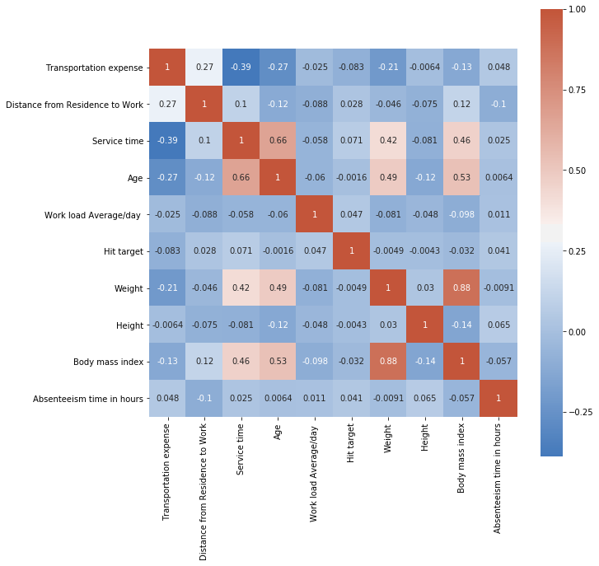

From correlation analysis we have found that Weight and Body mass index has high correlation (>0.8), so we have excluded the Weight column.

ANOVA:
P value for variable ID is 7.161548605665062e-62
P value for variable Reason for absence is 5.524581413945653e-87
P value for variable Month of absence is 0.19141618354249687
P value for variable Day of the week is 5.676667929219597e-10
P value for variable Seasons is 4.28544574012498e-19
P value for variable Disciplinary failure is 6.179328798017352e-43
P value for variable Education is 5.2285228885744484e-30
P value for variable Son is 1.4849609169999582e-32
P value for variable Social drinker is 2.6812726934433986e-37
P value for variable Social smoker is 1.0493398744082322e-42
P value for variable Pet is 3.3455390312014584e-35

Here P value of " Month of Absence" is 0.19141618354249687 which is greater than the threshold value 0.05.
My Hypothesis is-
H0= Independent varaible explain our Target variable.
H1= Independent varaible does not explain our Target variable.
If p> 0.05 then Reject the NULL Hypothesis (H0), that means this particular Independent variable is not going to explain my Target Variable.
Now, in my case -
P value for variable "Month of absence" is 0.19141618354249687, that means 'Month of absence' is not explaining "Absenteeism time in hours"
conclusion-
we have Removed 'Month of absence' by Anova statistical Analysis and,
we have removed 'Weight' by correlation Plot Analysis.

2.2.4 Feature Scaling
Feature scaling is a method used to standardize the range of independent variables or features of data. In data processing, it is also known as data normalization and is generally performed during the data preprocessing step. Since the range of values of raw data varies widely, in some machine learning algorithms, objective functions will not work properly without normalization. For example, the majority of classifiers calculate the distance between two points by the Euclidean distance. If one of the features has a broad range of values, the distance will be governed by this particular feature. Therefore, the range of all features should be normalized so that each feature contributes approximately proportionately to the final distance. Since our data is not uniformly distributed as we have seen in (2.1 Pre Processing) we will use Normalization as Feature Scaling Method.

2.1.5 Principal Component Analysis
Principal component analysis is a method of extracting important variables (in form of components) from a large set of variables available in a data set. It extracts low dimensional set of features from a high dimensional data set with a motive to capture as much information as possible. With fewer variables, visualization also becomes much more meaningful. PCA is more useful when dealing with 3 or higher dimensional data. After creating dummy variable of categorical variables the shape of our data became
93 columns and 714 observations in PYTHON and (59 columns,714 observations in R) this high number of columns leads to bad accuracy.

Variation of Principal components in Python :
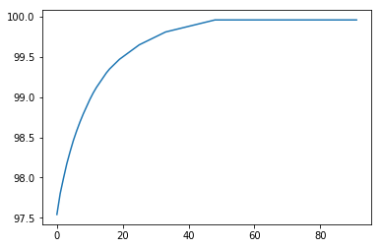

We have applied PCA algorithm on our data and from the above graph we have concluded that 30 variables out of 107 explains more than 95% of data. So we have selected only those 30 variables to feed our models.

Variation of Principal components in R :
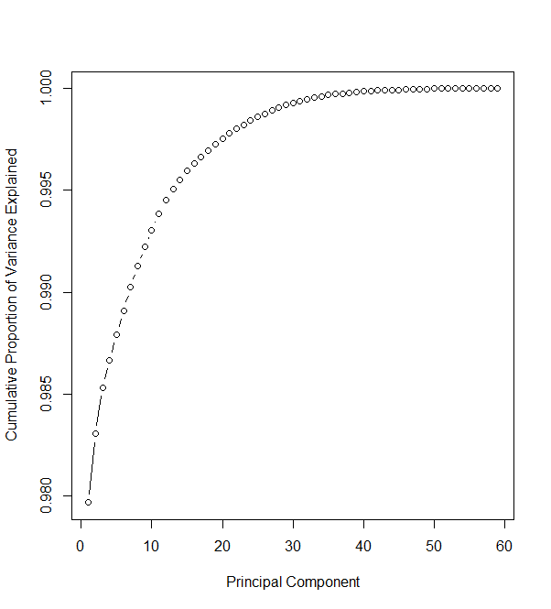

We have applied PCA algorithm on our data and from the above graph we have concluded that 30 variables out of 59 explains more than 95% of data. So we have selected only those 30 variables to feed our models.

2.2 Modeling
After a thorough preprocessing we will be using some regression models on our processed data to predict the target variable. Following are the models which we have built –

2.2.1 Multiple Liner Regression
Linear Regression is one of the statistical methods of prediction. It is applicable only on continuous data. To build any model we have some assumptions to put on data and model. Here are the assumptions to the linear regression model.

Multiple Linear Regression | R | PYTHON
RMSE Train | 0.000239 | 0.0005389956165122671
RMSE Test | 0.000293 | 0.0042534939026206324
R^2 Test | 0.9999999995 | 0.999999880694092

2.2.2 Decision Tree
A decision tree is a decision support tool that uses a tree-like graph or model of decisions and their possible consequences, including chance event outcomes, resource costs, and utility. Each branch connects nodes with “and” and multiple branches are connected by “or”. It can be used for classification and regression. It is a supervised machine learning algorithm. Accept continuous and categorical variables as independent variables. Extremely easy to understand by the business users. Split of decision tree is seen in the below tree. The RMSE value and R^2 value for our project in R and Python are –

Decision Tree | R | PYTHON
RMSE Train | 5.5615277 | 3.022810778490771e-16
RMSE Test | 5.2662989 | 1.8599622199011085
R^2 Test | 0.8566885 | 0.9771882389279765

2.2.3 Random Forest
Random Forest is an ensemble technique that consists of many decision trees. The idea behind Random Forest is to build n number of trees to have more accuracy in dataset. It is called random forest as we are building n no. of trees randomly. In other words, to build the decision trees it selects randomly n no of variables and n no of observations to build each decision tree. It means to build each decision tree on random forest we are not going to use the same data. The RMSE value and R^2 value for our project in R and Python are –

Random Forest | R | PYTHON
RMSE Train | 0.06027517 | 0.7829312646083995
RMSE Test | 0.09982425 | 1.0642907496085376
R^2 Test | 0.78762025 | 0.992530850649832

2.2.4 Support vector Regression (SVR)

Support Vector Machine can also be used as a regression method, maintaining all the main features that characterize the algorithm (maximal margin). The Support Vector Regression (SVR) uses the same principles as the SVM for classification, with only a few minor differences. First of all, because output is a real number it becomes very difficult to predict the information at hand, which has infinite possibilities. In the case of regression, a margin of tolerance (epsilon) is set in approximation to the SVM which would have already requested from the problem. But besides this fact, there is also a more complicated reason, the algorithm is more complicated therefore to be taken in consideration. However, the main idea is always the same: to minimize error, individualizing the hyperplane which maximizes the margin, keeping in mind that part of the error is tolerated.

SVR | R | PYTHON
RMSE Train | 5.4500204 | 11.199683762156287
RMSE Test | 8.6579865 | 9.724575339184948
R^2 Test | 0.7318553 | 0.37646611997817603

2.2.5 Gradient boosting
Gradient boosting is a machine learning technique for regression and classification problems, which produces a prediction model in the form of an ensemble of weak prediction models, typically decision trees. It builds the model in a stage-wise fashion like other boosting methods do, and it generalizes them by allowing optimization of an arbitrary differentiable loss function.

Gradient boosting | PYTHON
RMSE Train | 0.0016674934820754559
RMSE Test | 0.6505230395132787
R^2 | 0.9972095391506077

Chapter 3
Conclusion
In this chapter we are going to evaluate our models, select the best model for our dataset and try to get answers of the asked questions.

3.1 Model Evaluation
In the previous chapter we have seen the Root Mean Square Error (RMSE) and R-Squared Value of different models. Root Mean Square Error (RMSE) is the standard deviation of the residuals (prediction errors). Residuals are a measure of how far from the regression line data points are, RMSE is a measure of how spread out these residuals are. In other words, it tells you how concentrated the data is around the line of best fit. Whereas R-squared is a relative measure of fit, RMSE is an absolute measure of fit. As the square root of a variance, RMSE can be interpreted as the standard deviation of the unexplained variance, and has the useful property of being in the same units as the response variable. Lower values of RMSE and higher value of R-Squared Value indicate better fit.

3.2 Model Selection
From the observation of all RMSE Value and R-Squared Value we have concluded that Linear Regression Model has minimum value of RMSE and it’s R-Squared Value is also maximum (i.e.0.99 ) in both R and Python.
The RMSE value of Testing data and Training does not differs a lot this implies that it is not the case of overfitting.

3.2 Answers of asked questions

1. What changes company should bring to reduce the number of absenteeism?

Ans: The Changes which company should bring to reduce the number of absenteeism –

- It is observed that employee with low education have maximum absentee time.

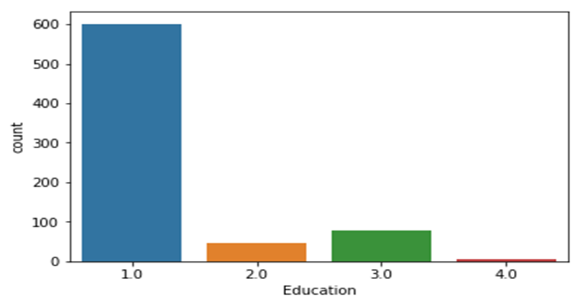
From above graph we can see- the employees holding master and Doctor are very less in number (4) but their average absent hours are 5 hrs (not much less as compared to others degree holders) see the below bar graph-

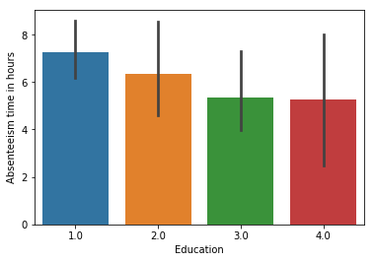
The company should also consider those Higher degrees Employees.

- Number of son:

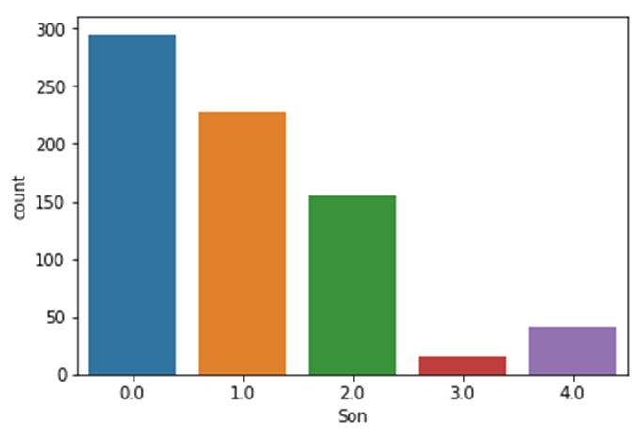
By comparing above and below graph- More number employees having no children work in company and they absent less .
So in order to reduce absenteeism hours we need to hire bachelor candidates according to analysis.
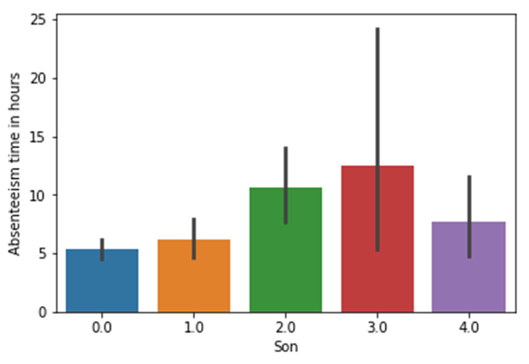

- More employees are social drinker and they contribute more towards absent.
Therefore we should hire employees who are not a social drinker. See below graph count plot and bar plot-

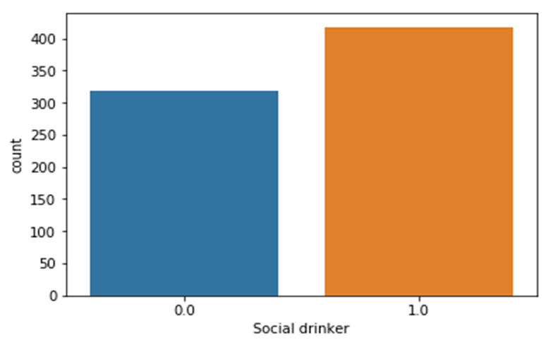

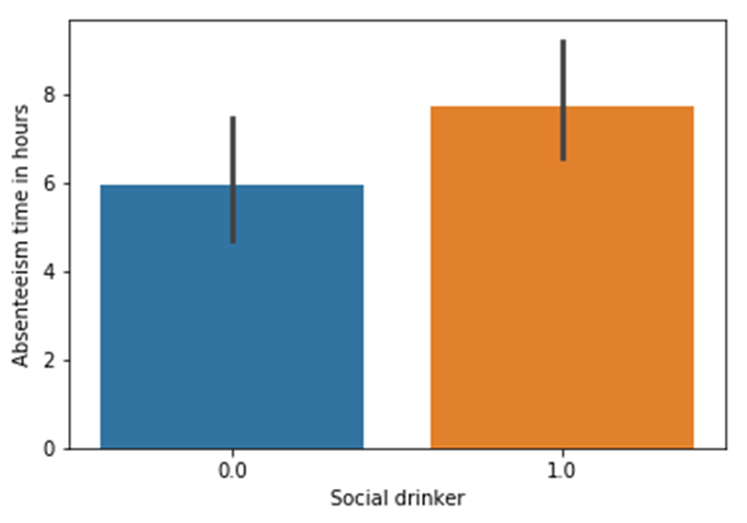

- The social smoker are less in quantity but these less quantities contribute more in absenteeism time.
So, if we fire out those employees or hire more number of non -social smoker which might
Reduce absenteeism hours. Observe and compare both the below count plot and bar plot-

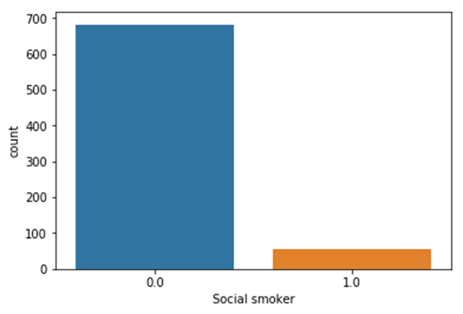

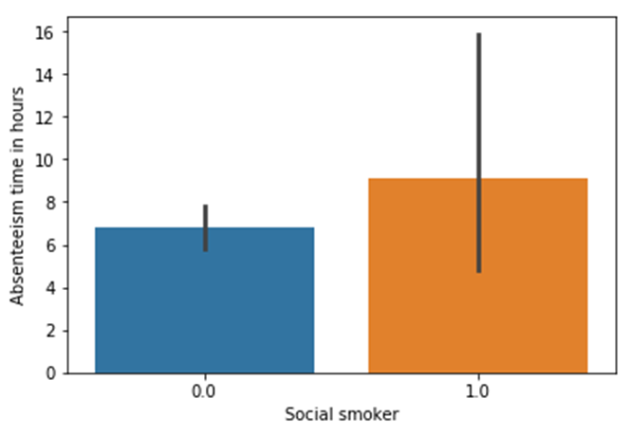

- Less no. of senior employees (total number is 8) who contribute more absenteeism hours
may be because of age factor they become more ill for longer duration and subsequently
more absent .
Therefore we need to recruit more and more youngster in the company.

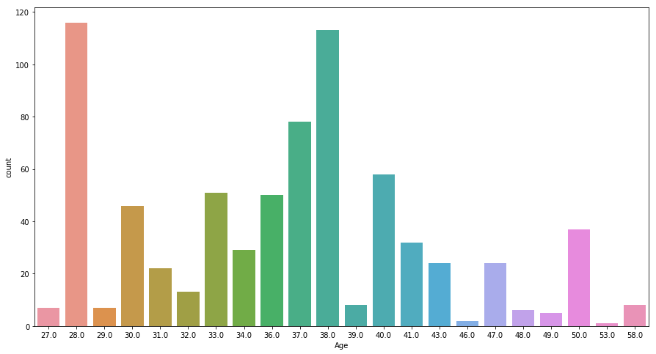

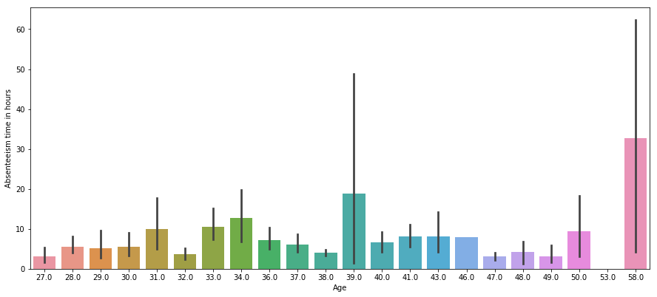

- In Hit target- The employees who achieved Hit target 100 are very less in number but they contribute more toward absent as compared to other middle Hit target achiever who are more in number.
Therefore, the company should also focus on 100 hit target achiever little bit although they did good.

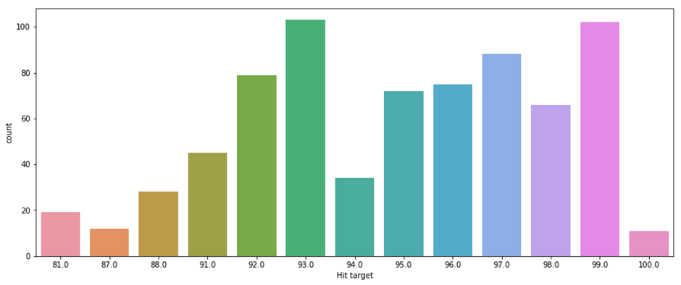

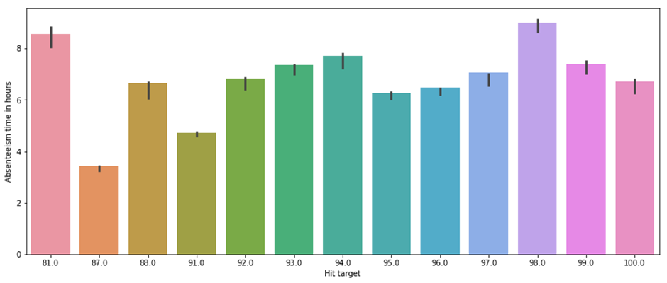

- See below employee whose ID is 3 absent more number of times and little bit ID no. 28. But they did not absent more hours in average.
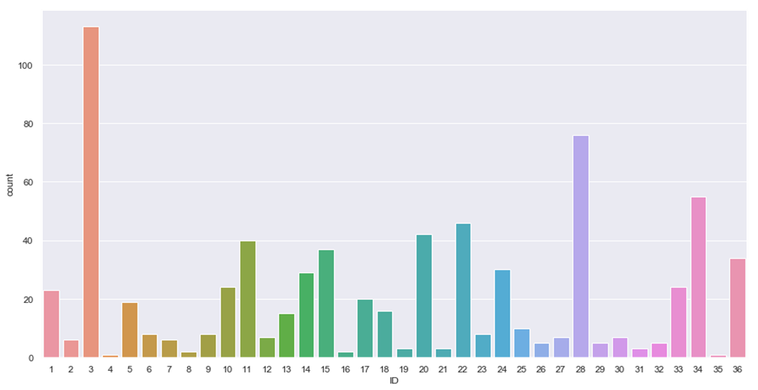
Now see in below bar graph employees with ID 9 and 7 have contributed more towards absenting hours in average. Therefore the company need to focus on them.
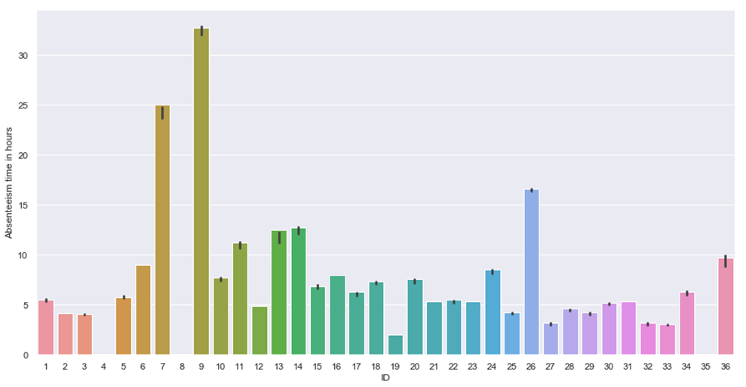

- Discipline refers to the actions imposed by an organization on its employees for failure to follow the organization's rules, standards, or policies. ... A more effective approach now being used by many companies recognizes good performance and encourages employee commitment to the organization and its goals.

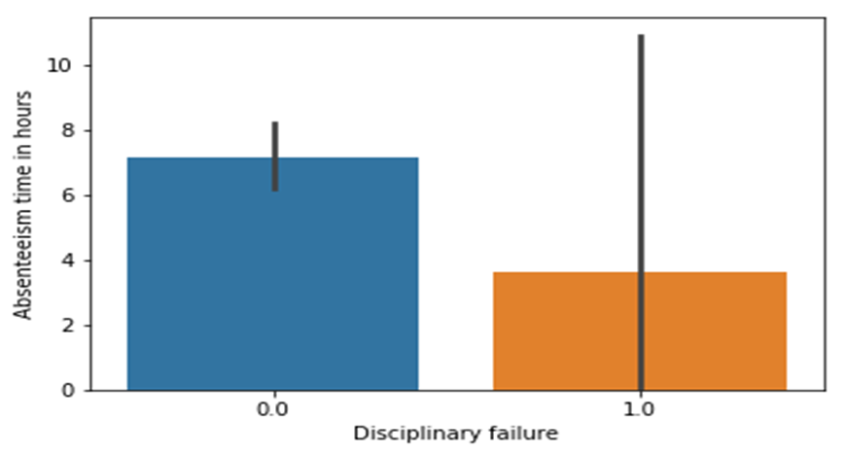
Here from both above and below graph we conclude that the employees who follow the rules and regulation also absent more. Therefore, company’s owner need to look after those employees who follow more discipline.

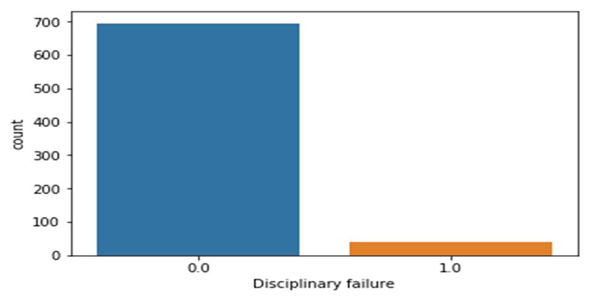

- With “ Reason for absence” we can see disease no. 9 (Diseases of the circulatory system) affects more to the employees which causes more absenting hours in average.

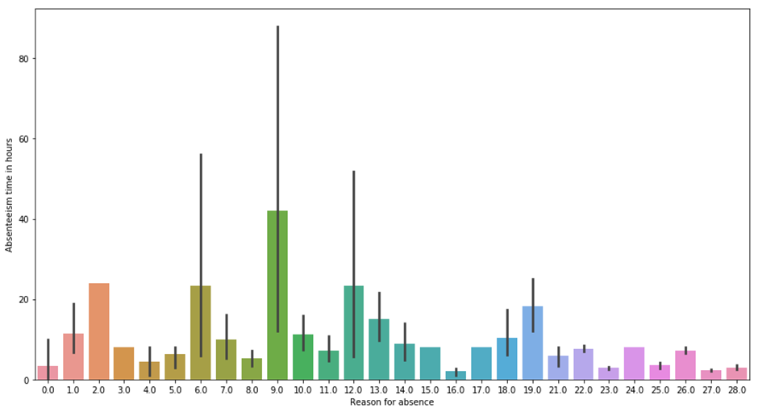

2. How much losses every month can we project in 2011 if same trend of absenteeism continues?
Ans: # output: Loss for every month in hours
#
# 1] # january
# [1] 77.09924
# [1] 2 # February
# [1] -17.82773
# [1] 3 # March
# [1] -19.63254
# [1] 4 # April
# [1] -20.24614
# [1] 5 # May
# [1] -16.93994
# [1] 6 # June
# [1] -19.23701
# [1] # July
# [1] -17.37784
# [1] 8 # Aug
# [1] -18.43026
# [1] 9 # september
# [1] -15.41679
# [1] 10 # october
# [1] -12.58831
# [1] 11 # November
# [1] -12.46213
# [1] 12 # december
# [1] 377.1544

Appendix
Extra Figures
Relationship of our target variable (Absentee time in hour) with other variables.
- With “Age”
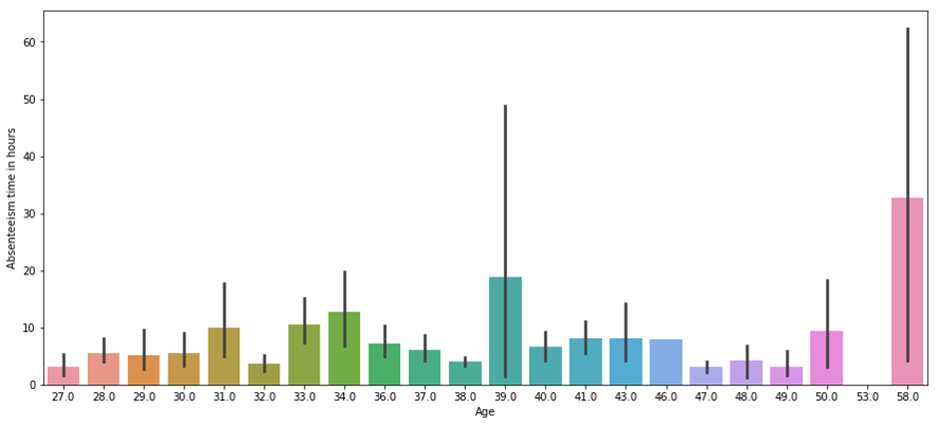

- With “Body mass index”
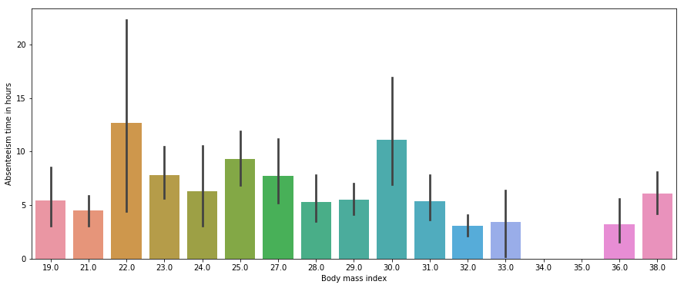

- With “ seasons”:
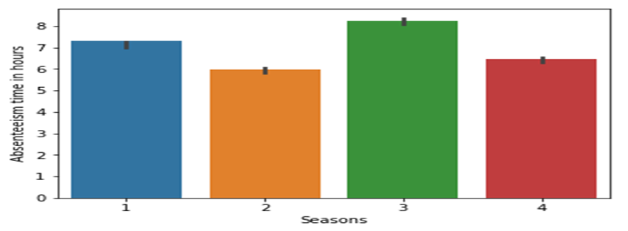

- With “ Days of week” :

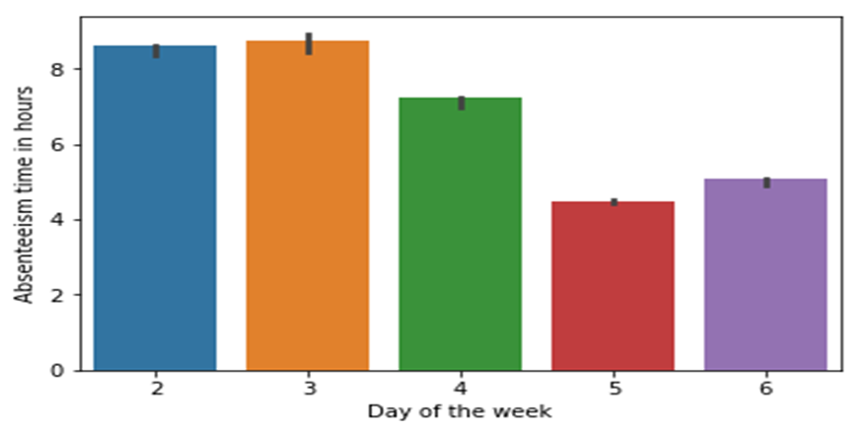

- With “Month of Absence” :

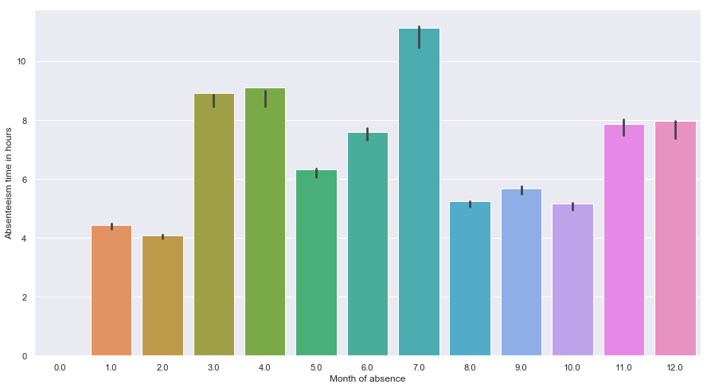

References

- For Data Cleaning and Model Development -
https://video.edwisor.com/video/H1PTA5IOrf

https://video.edwisor.com/video/SyuTR58dSG

https://www.udemy.com/machinelearning/learn/v4/t/lecture/10459548?start=0

- For PCA -
https://www.udemy.com/machinelearning/learn/v4/t/lecture/10628128?start=0

- For Visualization –
https://www.youtube.com/watch?v=z7ZINBk8EUk&list=PL998lXKj66MpNd0_XkEXwzTGPxY2jYM2d

